**Pre-work Materials: LO Advanced Analytics**

In preparation, below is some important information:

1. Introductory video message from GAMMA Leader, Stephan Thiel, click [here](http://bcgnavigator.bcg.com/Video/brightcove.asp?Video_ID=5588987802001) to watch.
2. Quick Reference Guide on the virtual classroom landscape is below
3. Install Excel Solver [Open Excel > File Options. Click on Add-Ins and select Solver Add-in and then click OK].
4. Exercise Files [please download and save both files on your Desktop] required:
5. L. PLANT2MKT_Example.xlsm: <https://bcg01.egnyte.com/dl/CaJBIcLCLz>
6. L. INVENTOPT_Example.xlsm: <https://bcg01.egnyte.com/dl/LOLxTLC9rt>

We also recommend that you acquire a **second screen** to get most out of the exercises. If it isn’t possible, don’t worry, you will still be able to follow through the session.

Should you have any questions or concerns please [email](mailto:LABTalkTeam@bcg.com) the team.

Best wishes

**AA L&D Team**

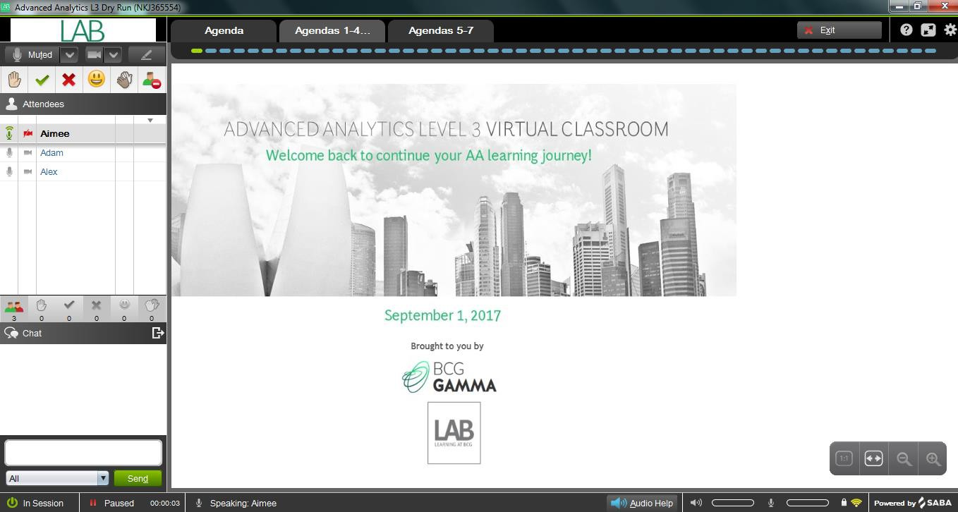

|  |  |
| --- | --- |
| **Saba Classroom** **Quick Reference Guide for Participants** | |
| **Exit**  **Emoji icons**  **Trainer**  **Participant**  **1**  **3**  **Chat Box**  **2** | |
| **Screen Element** | **Description** |
| **1 Participant Panel**   * Emoji icons * Chat | The Participant Panel contains **emoji icons**. Participants can respond to questions asked by trainers by  clicking on a green check for Yes or red X for No or use the other icons  that are available as appropriate.  The **Chat box** is used to type in questions to the trainers, comments or input you have to share. Type in the Chat box and click **Send**. The text typed into the Chat box cannot exceed 256 characters.  You can also raise your virtual hand  and we will unmute your mic and you can ask your question.  If you need to unmute your microphone to speak, click the red microphone  to the left of your name in the participant panel. The microphone turns green. To mute when not speaking, click the green microphone  . The microphone will turn red to indicate it is muted. |
| **2 Audio Help** | If you experience any audio challenges while in Saba Classroom, click the **Audio Help** button. Audio help is used to:   1. Trouble shoot audio VOIP issues by ensuring the speaker and the microphone selected are the correct headset. 2. Change from VOIP to Dial-in. 3. Adjust the volume on your speaker or microphone. |
| **3 Slide Resizing Panel** | Use the **Slide Resizing Panel** to adjust the size of slides for viewing. Mouse over the bottom right hand  corner of the Saba Classroom screen and the Slide Resizing Panel displays. **It allows you to zoom per your preference to increase or decrease the size of the slide or click the Scale to Fit button to snap the slide to the full size of the screen.** |
| **Tips for best learner experience:**   * Limit the number of applications open on your computer to only those you need. Close out everything unneeded (Outlook, Skype, etc.) on your computer to conserve the use of bandwidth for Saba Classroom. * Participate in the session from a quiet location with excellent bandwidth. * Connect a good headset to your computer in advance of the session to use VOIP for the best audio experience. * Mobile devices are prohibited from this session. Please do not join the training via your smartphone or tablet. They do not work in Saba Classroom. Please use a computer to join the training.   Email [LAB Talk Team](mailto:LabTalkTeam@bcg.com) if you need technical support when joining Saba Classroom for the training | |